PF Lab Assignment

**Name: Muhammad Zain Khan**

**Rollno: 24K-0838**

**Question 1.**

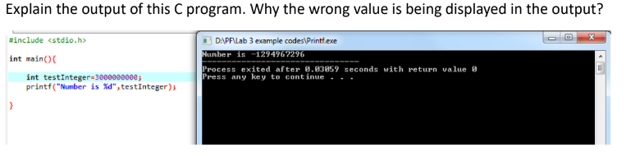

**Ans. This is because the data type “int” cannot hold very large number like the number in the given question, because the int data type is limited to a number which is 2147483647**

**Question 2.**

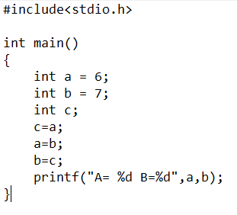

**Output**

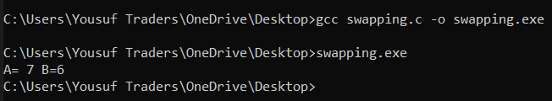

**Question 3**

**Output**

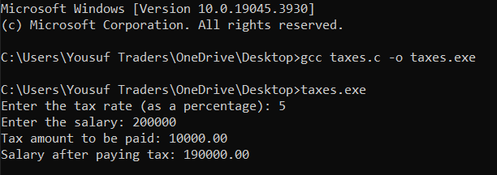

**Question 4**

**OUTPUT**

**Question 5**

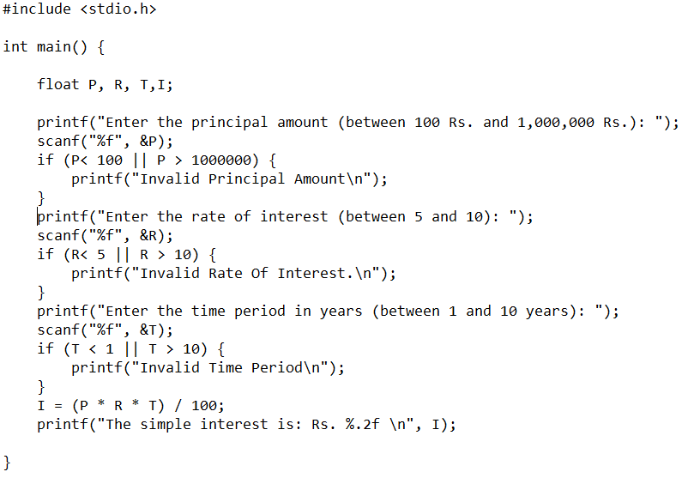

**Output**

**Question 6**

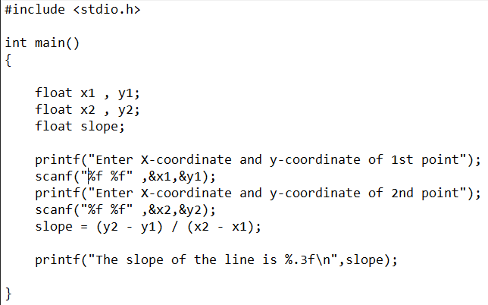

**Output**

